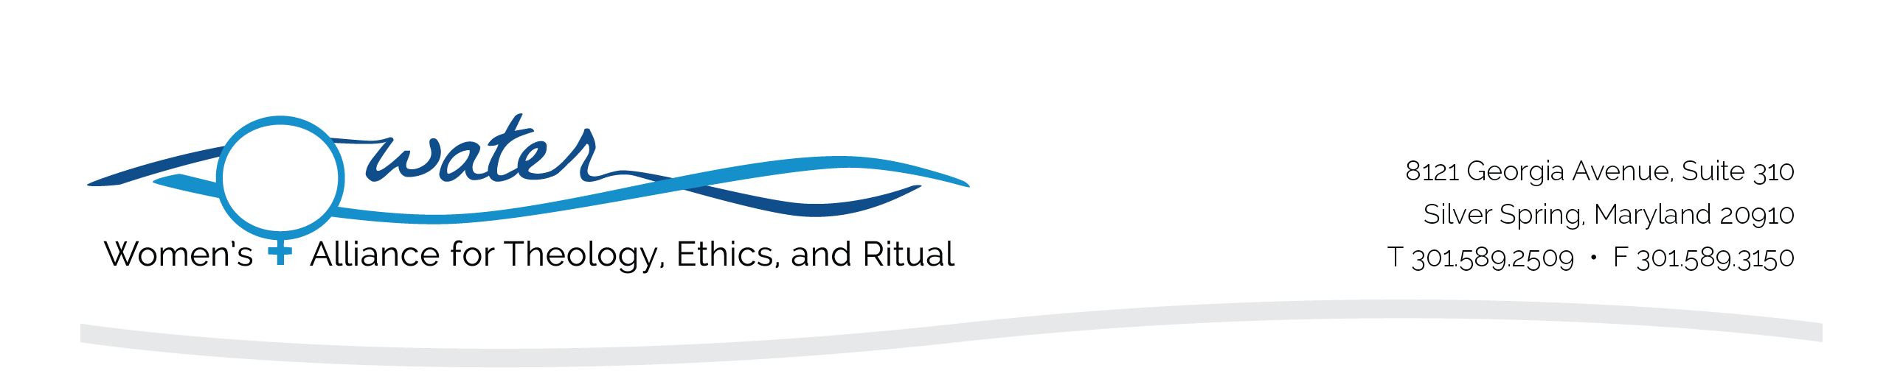

WATER Internship Application

Personal Data

Name: __________________________________________________________________
First Middle Last

Address: __________________________________________________________________
Street
__________________________________________________________________
City State Zip

Phone:______________________________________________________
Permanent Address: _____________________________________________
Permanent Phone: ______________________________________________
Please list the dates for which you are considering an internship (6 weeks minimum):

List office and computer skills/experience you have:

Languages spoken (indicate proficiency level):

Other skills you would like to mention:

List extracurricular and community activities:

Work Experience

List all work experiences, beginning with the most recent. Attach additional sheets if needed.
Please attach a resume along with this application.

- Dates of Employment: _________ to _________

Employer: ______________________________________________________________
Title/Duties:_____________________________________________________________ Address: _______________________________________________________________
Phone: ________________________________________________________________

- Dates of Employment: _________ to _________

Employer: ______________________________________________________________
Title/Duties:_____________________________________________________________
Address: _______________________________________________________________
Phone: ________________________________________________________________

- Dates of Employment: _________ to _________

Employer: ___________________________________________________________ Title/Duties: __________________________________________________________ Address: _______________________________________________________________
Phone: _________________________________________________________________

- Institutional Information (if applicable)

College/University: ________________________________________________________ Major: _________________________________________________________________ Faculty Advisor: __________________________________________________________ Phone: ____________________________ Email: ________________________________

Academic Credit Arrangements
Please list the credits you will be receiving from your institution for your internship (1) and describe the evaluation WATER is required to complete for your institution (2). Please have your institution contact WATER (waterstaff@hers.com) to confirm all arrangements.
(1)
(2)
Faculty Advisor Agreement (if applicable):

I endorse this student's candidacy for an internship at WATER. I acknowledge that I am the Faculty Advisor for this student for the duration of this program and that I will receive all evaluations for this student.

Name: _______________________________________________________________ Address: _____________________________________________________________ Phone: ________________________ Email: _________________________________
Signature: _____________________________________ Date: ___________________

Essay

Please include an essay (limit two double-spaced, 12 point typed pages) that describes:

- Your background and related experience
- Your overall personal goals for the internship, including any issues or concerns on which you wish to work while at WATER

Letters of Recommendation

Please request two letters of recommendation from faculty, a work supervisor, or religious leader. Your recommenders should send the letters directly to WATER by email or postal mail (see below).

Emergency Information

Emergency Contact Person:

Name: _______________________________________________________________ Address: _____________________________________________________________ Phone: (Day)_______________________ (Night) ____________________________ Email: _______________________________________________________________

Internship Agreement

I understand that the Internship Application and all supporting materials submitted to WATER will not be returned or transferred to other institutions or potential employers. I certify that the information provided is complete and accurate. I understand that housing, meals, travel and miscellaneous expenses will be my responsibility.

Signature: _____________________________________________ Date: ____________

Please submit all application materials to:
Women’s Alliance for Theology, Ethics, and Ritual | ATTN: Internship Program
8121 Georgia Avenue, Suite 310 | Silver Spring, MD 20910-4933 USA
Fax: 301.589.3150 | waterstaff@hers.com

See website for more information and deadlines: https://www.waterwomensalliance.org/internship/

